# Assignment 1 – C14337041

# The Data

Unless explicitly specified, all data being used has been taken from the 2011 census. Figures are also as stated.

# The Map

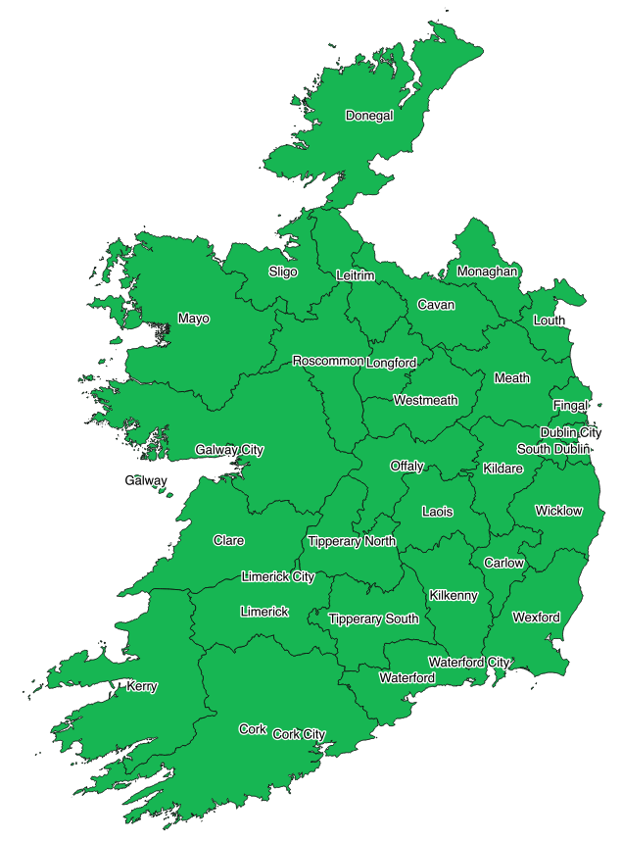

The above map is used for this assignment. It is broken up using the electorate constituencies of Ireland. Some counties have been sub-divided (e.g. Dublin, Cork, Galway) into smaller regions. Also, please note that The Galway label accounts for the entire county of Galway (excluding Galway city) and not just the Achill Islands.

# Post-Secondary Education vs No Post-Secondary Education

# 

* Post-Secondary Education is a Level 6 Higher Diploma or Greater

# Socio Economic Cat A vs Socio Economic Cat B

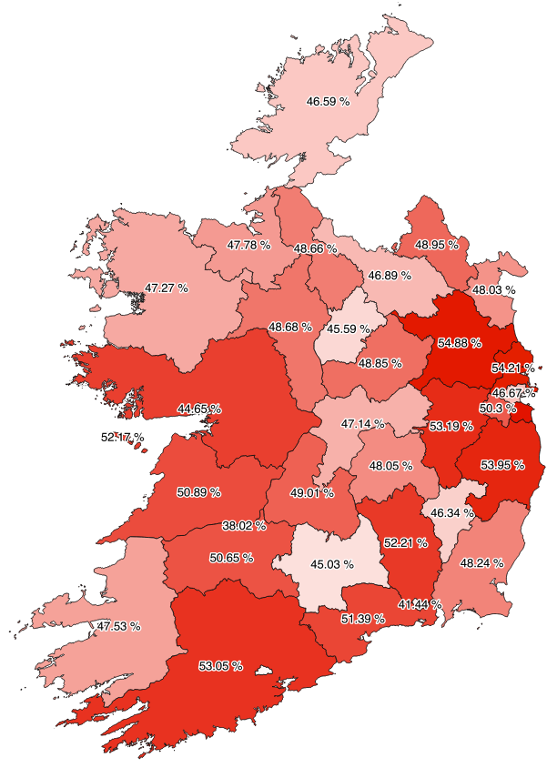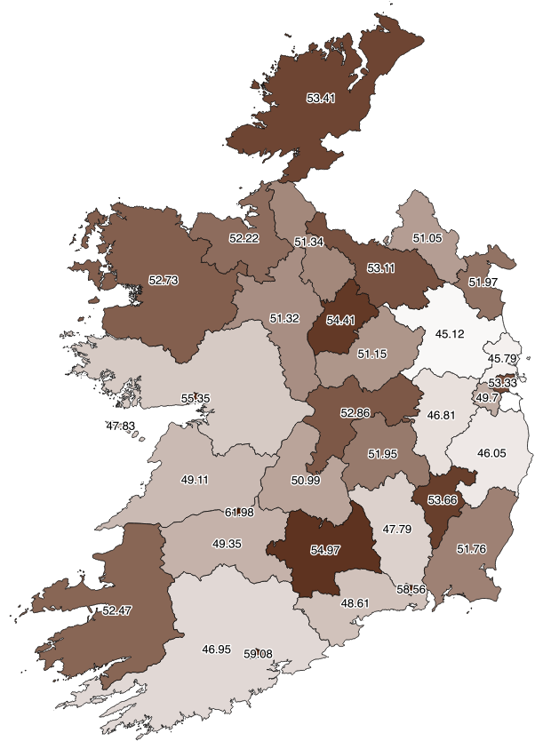

* Cat A consists of Professional, Managerial, Technical and Skilled workers.
* Cat B consists of Non-Manual, Semi-Skilled, Un-Skilled and Other Workers.

# 2011 Employment Figures vs 2016 Employment Figures

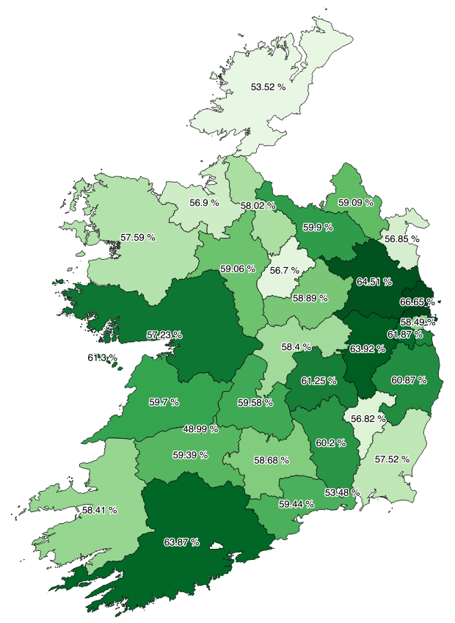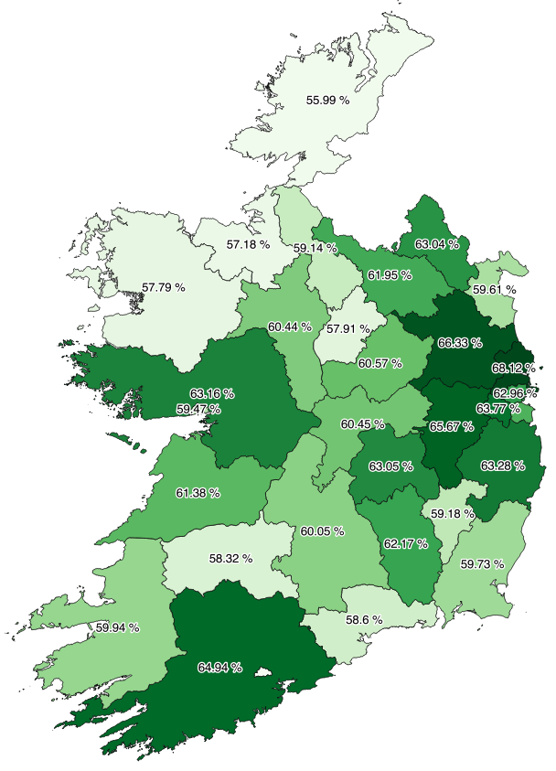

* Employment Figures include those in full time employment, looking after a family member or other lines of work.

# 2011 Unemployment Figures vs 2016 Unemployment Figures

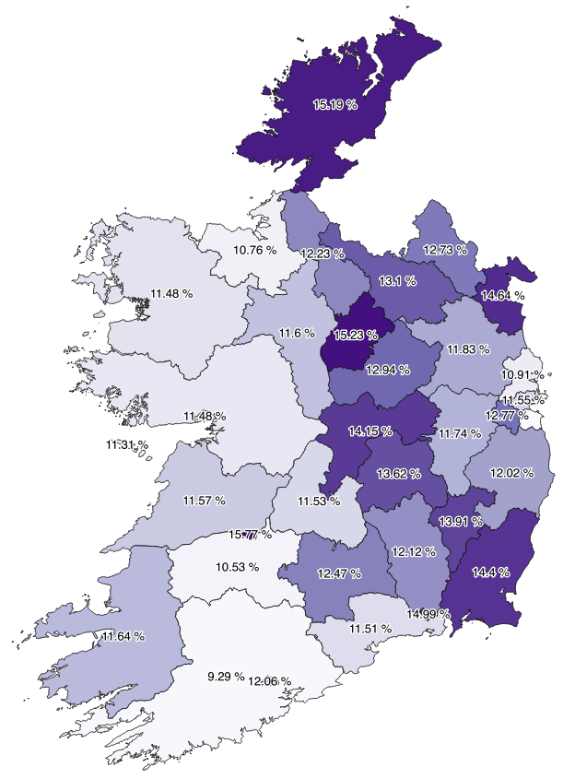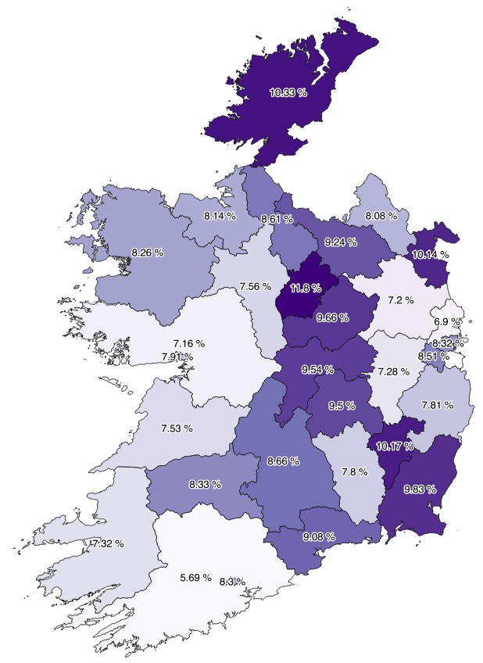

* Unemployment figures include those who are currently looking for work and those who have lost or have given up their jobs.

# Findings

Below is a list of findings based on the above data.

## Education

* In 2011, on average close to 75% of the population had no form of Post-Secondary Education.
* In 2011, most of the people who had a form Post-Secondary Education were located in urban areas such as Dublin, Cork, Galway.
* In 2011, lower numbers of Post-Secondary Education were recorded in rural areas as opposed to urban areas.

## Socio Economic

* In 2011, built up areas such as Dublin and Cork possessed higher numbers of Cat A for socio economic groups. This may indicate that more office jobs or jobs which require degrees exist in these areas.
* In 2011, rural areas such as Kerry and Mayo possessed higher numbers of Cat B for socio economic groups. This may indicate that more manual jobs such as farming exist in these areas.
* In 2011, Quite an even split of Cat A and Cat B socio economic groups can be seen across the board.

## Employment

* Between 2011 and 2016, urban areas such as Dublin and Cork saw higher levels of employment as opposed to rural areas.
* Between 2011 and 2016, unemployment levels feel right across the country with no county showing an increase in unemployment levels. Higher levels of unemployment still existed in many rural areas however.
* Between 2011 and 2016, higher levels of employment were seen where people with a form of Post-Secondary Education resided.

Based on the findings, it can be said that there is a high correlation between educational achievement and employment prospects. On top of this, it can also be said that holders of a primary degree or higher qualification are concentrated in certain areas such as Dublin or Cork. Finally, it can also be said that there was a decent increase in levels of employment and decrease in levels of unemployment across the country.